Algebra 3-4 Name: ____________________

Chapter 4 Re-Test Block: ________

For problems 1 – 3, graph and label the vertex and axis of symmetry.
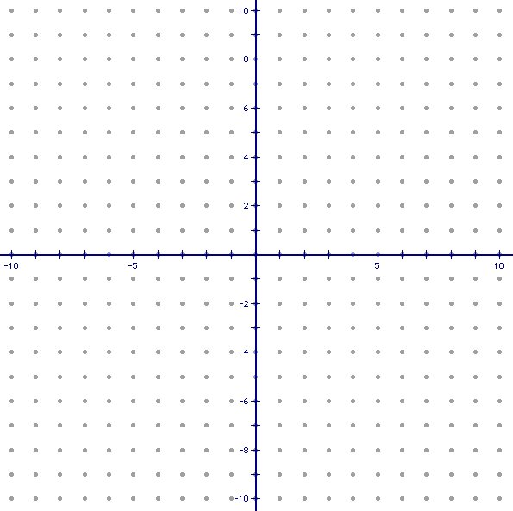
1. 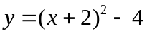

2. 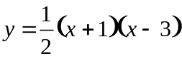

3. 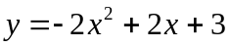

For problems 4 – 5, write the quadratic function in standard form.

4. 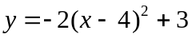 4. Standard Form: __________________

5. 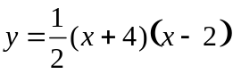 5. Standard Form: __________________

For problems 6 – 7, write the quadratic function in intercept form and then find the zeros of the function.

6. 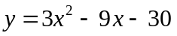 6. Intercept Form: ________________

Zeros: ________________________

7. 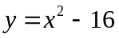 7. Intercept Form: ________________

Zeros: ________________________

For problem 8, choose the correct intercept form of the quadratic function.

8. 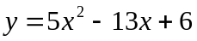 8. __________

A. y = (5x + 3)(x + 2)

B. y = (5x + 3)(x – 2)
C. y = (5x – 3)(x + 2)

D. y = (5x – 3)(x – 2)
For problems 9 – 10, write the quadratic function in vertex form and identify the vertex.

9. 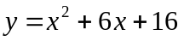 9. Vertex Form: ____________________

Vertex: _________________________

10. 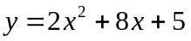 10. Vertex Form: ___________________

Vertex: _________________________

For problems 11 – 12, graph the quadratic inequality.
11. 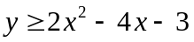

12. 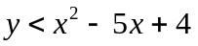

For problems 13 – 14, solve the quadratic inequality.

13. 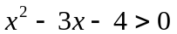 13. _________________________

14. 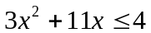 14. _________________________

For problem 15, find what is needed.

15. Given below are three solutions students turned in on a test. Are these solutions the same? Explain your reasoning.

Student A: y = 3(x – 3)² Student B: y = 3x² – 18x + 27 Student C: y = 3(x – 3)(x – 3)

15. Yes or No, Why? _____________
________________________________
________________________________

